Laboratory Trial for Mini-Grids

University of Bath

Since October 2022, the University of Bath has been developing and extending a laboratory demonstrator, capable of replicating mini-grids that comprise of PVs, batteries, inverters, loads as shown in Figures 1-2. Addition to hardware integration, the team developed Data-Logging and Control Capacities, and opened communication channels between the mini-grid hardware and data and energy management software. The python script is open sourced at: <https://github.com/CuttySark1869/SolarMiniGrid>. A preliminary data logging and mini-grid control test is shown in Figure 3. The next step is to test the control with selective Kenya settings to investigate the effects of energy management system in the presence of differing PV profiles.



Figure 1: Layout of the Mini-Grid Lab Demonstrator

Table I: Specification of the Mini-Grid Lab Demonstrator

|  |  |  |
| --- | --- | --- |
| Battery | | 24V, 38Ah, 9.5A (charge cont.),  200A (discharge, 1min) |
| PV Emulator | | 80-150V |
| Variotrack PV MPPT Tracker | | Max charging current: 80A |
| Xtender | Grid Interface (bidirectional) | Max charging current: 55A |
| Load Inverter | 2000VA |

Table II: Data-Logging and Control Capacities. The values in **bold** is controllable.

|  |  |  |
| --- | --- | --- |
| Battery Management | | Battery current/voltage/SoC |
| Variotrack PV MPPT Tracker | | PV voltage, **charging current** |
| Xtender | Grid Interface (bidirectional) | Grid voltage/current/frequency,  **charging/discharging current** |
| Load Inverter | Load **voltage**/current/frequency |
| Note:   1. All devices have control/sample rate of 1/second. 2. The charging current from PV is determined by MPPT algorithm but can be overridden by setting the maximum charging current below the MPPT value. 3. The data-logging and control can be done over host PC via python scripts. The script uses .csv files to interface with energy management systems and can also be deployed in real-time. The python script is open sourced at: <https://github.com/CuttySark1869/SolarMiniGrid> | | |

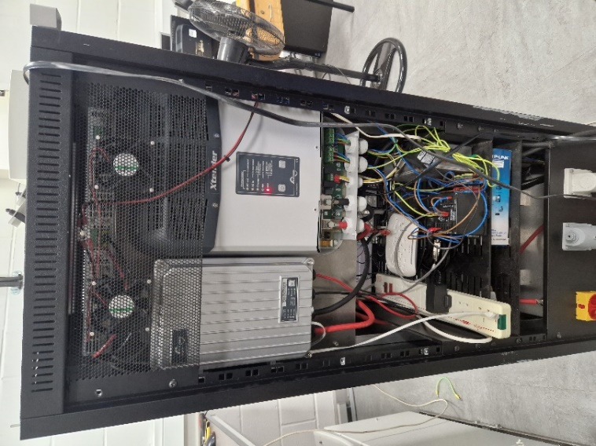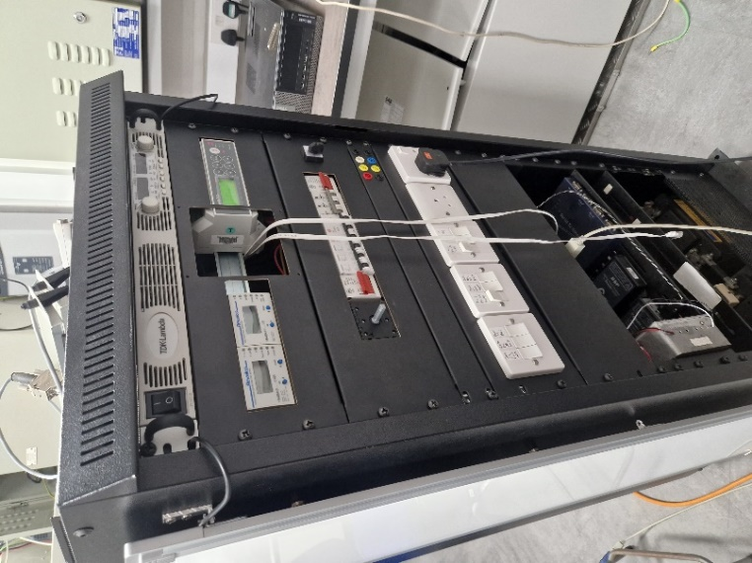

Figure 2: Photo of the Mini-Grid Lab Demonstrator

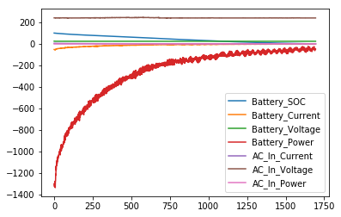

Figure 3: Preliminary data logging and mini-grid control test.